KARST TRAINING WORKSHOP

A BRIEF PRESENTATION ON KARST HYDROLOGY AND GEOMORPHOLOGY

Dr. Tran Tan Van

Karst Research Center

Research Institute of Geology and Mineral Resources (RIGMR)

Tel: 84-4-854-3107, Fax: 84-4-854-2125

Email: trantv@hn.vnn.vn

CUC PHUONG NATIONAL PARK - DECEMBER 2003

Aknowledgement: This presentation is prepared on the basis of Prof. Ek C. M. (Liege University, Belgium) lecture notes, with practical illustrations and examples taken from VIBEKAP (Vietnamese-Belgian cooperative project on “Rural development of karst mountainous areas of Northwest Vietnam by sustainable water and land use and management and social learning: its conditions and facilitation”) and LLINC (Vietnamese-Belgian cooperative project on “Improving the participation of stakeholders in the conservation of limestone landscape in Ngoc Son-Ngo Luong area, Hoa Binh province”) projects. Some examples and illustrations are taken also from the report on geological characteristics of the Pu Luong Nature Reserve, undertaken by the author and his colleagues with FFI financial support.

CONTENT

Introduction

Nature and characteristics of karst and karst water

Karst and karst water processes and factors

Physical behaviour of karst water

Structure and working of karst aquifers, springs and resurgences

Water tracing technique in karst hydrology

Speleological studies

Some environmental impacts specific to karst ecosystem - a few conclusions/ recommendations

INTRODUCTION

Karst is originally the German name of a limestone area in western Slovenia, former Yugoslavia, north-east of the Adriatic Sea;

It is derived from the Serbo-Croatian word Kras.

Typical “karst rocks”:

Limestones and dolostones (Ca, Mg)CO₃;

Other soluble rocks, e.g. gypsum, anhydrite (CaSO₄) and salt (halite, NaCl);

“Karst rocks” result specifically in unique “karst hydrology” (karst water) and “karst geomorphology”.

This brief presentation aims at:

Identifying karst features, karst formations and forms in the field, on maps, airphotos, satellite images etc.;

Understanding karst processes and their factors (especially geological and structural factors, karst hydrology or the interactions between water and its reservoir rock);

Introducing some environmental impacts specific to karst ecosystem due to its geomorphology and hydrology;

Introducing speleological studies;

Arriving at some general recommendations for a wise management of karst water and karst terrains.

The idea behind this presentation is the underground itinerary of water in karst rocks:

Water has strong ability in forming conduits in karst rocks;

But conduit morphology (shape, dimensions and orientation) in turn, has very important influence on the water dynamics;

From chemical viewpoint the interaction is also highly reciprocal:

Water dissolves rocks;

But the quality of water at each point depends upon the bedrock that was dissolved upstream.

The originality of the karst process is thus in its chemical aspect.

1. NATURE AND CHARACTERISTICS OF KARST AND KARST WATER

The original point of a karst circulation is the chemical process, which enables water to remove rock even without any kinetic energy or mechanical disintegration.

The general result is that water (even a whole river) tends to disappear, to sink in caves, chasms or canyons, abandoning meanwhile the surface landscape.

Karst terrains:

Very different from non-karst terrains;

Easily recognizable from airphotos, satellite images, topographic maps and in the field (example).

1.1. Typical karst forms

Some distinctive forms of karst are pits, caves, closed depressions, solution sculpture etc.;

None is always present;

All are specific of the karst circulation/evolution;

All are related, at some moment of their evolution, with the dissolution action of water.

Concretely:

Karren (in French: lapies): Minor dissolution forms of rock sculpture, carved by rainwater or by percolating water;

Closed depressions:

Dolines (sinkholes) - Small elementary depressions, usually circular;

Uvalas - Coalesced dolines;

Poljes - Large, often tectonically-controlled depressions, drained by an effluent river or more often by ponors (swallowholes, “potholes”).

These enable rainwater or streams to enter karst massives (Plate 2).

Blind valley: A valley that is blocked by some uplifting massive and all flows in it end with a swallowhole(s);

Dry valley: Further downstream, the valley becomes without water, which can cease being dry at a resurgence of the swallowed water.

1.2. Underground karst water conduits

Fissures: Most elementary, structurally controlled form of a karst net, can be enlarged by water corrosion;

Pits: Generally formed by fast descending water, thus usually the base is wider than the top (due to increase of kinetic energy);

Tubes: Formed by pressure flow, exhibiting thus a nearly circular cross-section.

Underground rivers: Often carry allochtonous sediments:

Differ from above by a free upper surface, thus an important interface with cave air;

Differ from surface rivers by absence of valley-sides (thus slopedebris) and possible existence of siphons;

Phreatic caves: Formed by rather standing water, incl. boxwork and spongework, i.e. microforms resulted from fine differential solution, with protrusion of calcite veins (in boxwork) or the less soluble parts of bedrock (in spongework).

In most caves, breakdowns can be very important.

1.3. Water table in karst – some initial discussion

WALTHAM et al. (1985): Difficult to identify a meaningful water table in karst area because fissure flow and conduit flow may be independent;

Existence of underground rivers, with waterfalls and sumps (siphons), indicates traditional “water table” doesn't exist in karst (Plate 5);

Plate 13, Fig.3 - boreholes made, wrong assumption about domed water table beneath crest-line.

Cavers explored 250 sinkholes. All cave entrances dry in dry season, thus without exploration impossible to assess the presence of water.

All caves deeper than 150 m displayed some dry-season flow, indicating role of fissure storage, but also role of cave exploration.

2. KARST AND KARST WATER PROCESSES AND FACTORS

2.1. Distinctive characteristics of karst process

2.1.1. Dissolution process and equilibrium

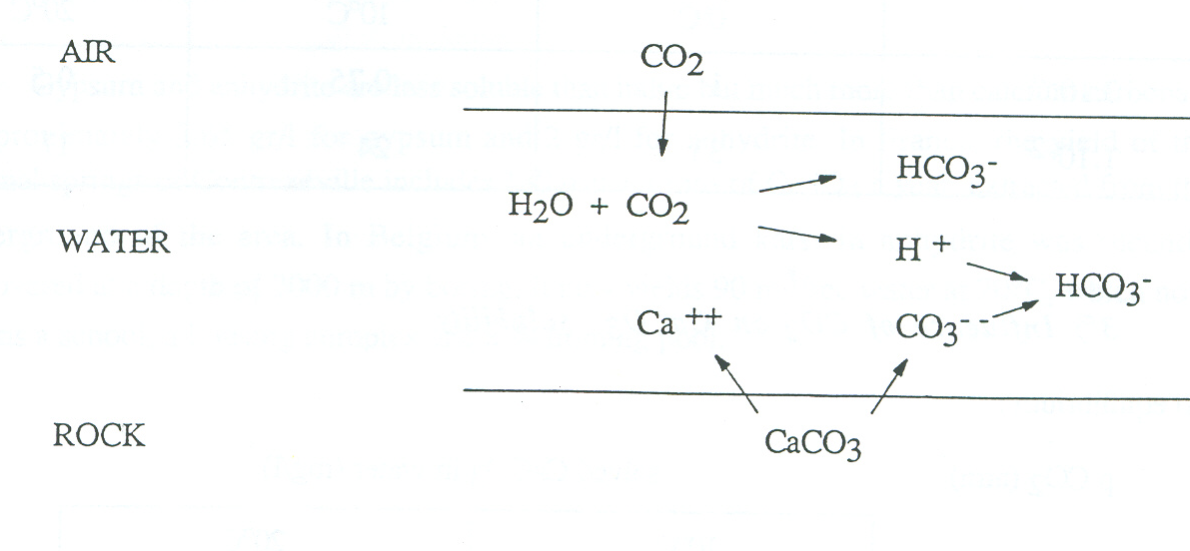
Global reaction: CaCO3 + H2O + CO2 = Ca (HCO3)2

Soluble products and equilibrium constants:

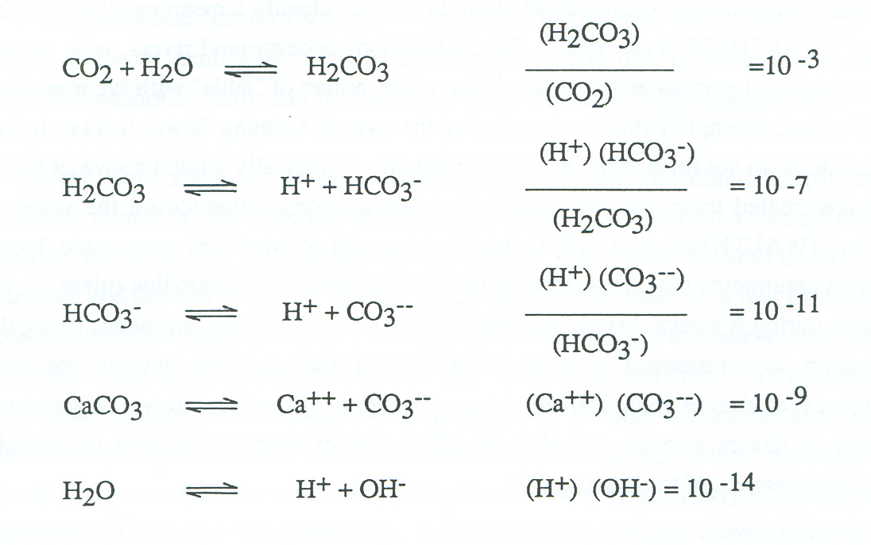

2.1.2. Dissolution of CaCO₃ in water containing CO₂

Henry's Law: p CO₂ (air) = D. (CO₂) (water)

Fig.1 - Examples. D varies according to temperature.
p CO2 (atm) | Solved CO2 (mg/l)
p CO2 (atm) | 0⁰C | 10⁰C | 20⁰C
3.10-4 | 1 | 0.75 | 0.5
1.10-2 | 33 | 24 | 17

2.1.3. Influence of CO₂ on CaCO₃ solubility

At equilibrium:
p CO2 (atm) | Solved CaCO3 in water (mg/l)
 | 10⁰C | 20⁰C
3.10-4 | ±60 | ±45
1.10-2 | ±200 | ±150

2.1.4. Other acids

Dissolution of limestone can be due to other compounds:

Inorganic: nitric acid from oxidation of ammonia in soils; sulfuric acid from pyrite or other sulfides in the bedrock etc.;

Organic: humic and other acids produced by plants or their decay.

2.1.5. Solution kinetics

Fig. 5 - According to Nernst's Law, a soft water corrodes limestone faster at the beginning than later on.

Fig. 6 - When two, even saturated waters of different origins, hence different characteristics, mix, a new attack on the rock starts.

Fig. 7 - Reaction rates increase when temperature rises.

2.1.6. Dissolution of non-carbonate rocks

Halite: very soluble, more than 300 g/l at normal temperature.

Thus halite outcrops are rare, except in arid areas (Jelfa, Algeria).

But underground caves in it are not rare (Cardona near Barcelona, Spain);

Gypsum and anhydrite: less soluble than halite but much more than calcium carbonate, approximately:

2.65 g/l for gypsum; and

2 g/l for anhydrite.

In Contrexeville (France), thermal springs produce 130 tons of CaSO₄ a year from underground;

In Belgium, an underground karst in anhydrite was recently discovered at a depth of 2000 m by boring.

2.2. Climatic factors of dissolution and their effects on karst conduits

2.2.1. Flow rate

Flow rate is the main factor of the enlargement of karst conduits, by both dissolution and mechanical erosion;

Fig. 8 and 9 show how much more carbonate can be dissolved in a rainy period, compared to a dryer period.

2.2.2. Aggressiveness

The more acid the water, the more aggressive it is towards limestone;

CO₂ is the main source of acidity (Fig. 2) but not the only one. Thus the use of pH in characterizing aggressiveness (Fig. 3).

In most underground streams atmospheric CO₂ (3.10⁻⁴ atm) is only part of the total CO₂. Another part is CO₂ of organic origin.

Fig. 2 and 3 distinguish “aggressive” from “super-saturated” waters. They show aggressiveness is also related to the content of previously dissolved carbonate. Some waters get saturated in carbonate before they reach limestone hence cannot corrode the latter any more.

2.2.3. Temperature

Temperature inversely affects the D coefficient (Fig. 1):

At the same atmospheric CO₂ pressure, the 0°C water dissolves twice as much CO₂ as the 18°C water;

But CO₂ is usually much more (1-10 times) abundant in warm regions than in cold ones.

Temperature enhances the chemical reaction rate:

Most reactions are twice as fast at 20°C as at l0°C. Hence, solution in warmer conduits is more favorable (Fig. 7).

0°C is an important limit in dissolution:

Below it, water freezes and practically does not dissolve any more limestone.

2.3. Action of water on its underground conduits: corrosion versus mechanical erosion

2.3.1. Usual cave evolution sequence

Dissolution (corrosion) stage;

Mechanical erosion-transportation stage;

Breakdown stage.

From a speleogenetic point of view, corrosion is the original, the earliest, and the determining factor of cave evolution.

But, in large conduits, the main morphological features are often not the consequence of corrosion, but the result of physical actions.

2.3.2. Dissolution (corrosion) stage

Initially there must be some discontinuity surfaces (fissures, cracks, bedding planes, cleavage etc.) in karst rocks, which are generally still rather tight;

Each contains very little water, whose velocity is thus very low and can not carry away solid particles;

Thus, dissolution is usually the only process initially.

2.3.3. Mechanical erosion-transportation stage

In enlarged conduits, water velocities increase and solid transport can occur. The volume of solid material carried away increases with time. Subterranean streams sometimes carry very far into the caves allogenic clastics, silt, sand, pebbles, even garbage;

In major underground rivers, dissolution can be reduced - even to zero - due to the saturation of water or the poor contact between water and rock. Instead, mechanical transport can become the main - not to say the only - erosion process;

2.3.4. Breakdown stage

Finally, when water disappears lower or abandon the conduit, breakdown can occur;

This can become an important, prominent process of cave evolution;

But it tends to block the cave if alone, i.e. it can last only if the debris are gradually carried away, e.g. by an underground flow, or sometimes by man action.

2.4. Deposits in karst conduits

Deposits can be authigenic, as speleothems and eboulis (fallen blocks), or allogenic, as fluvial sands and pebbles etc.

2.4.1. Authigenic deposits

Speleothems - most characteristic fills of caves;

Isotopic studies - information on their age, climatic and botanic conditions during their growth;

Other analyses (pollens, heavy minerals) - various events that occurred outside during their growth (vegetal evolution, volcanic activities etc.);

Rockfalls can be studied in terms of their age (through related speleothems), causes (through shapes and dimensions of blocks) and their evolution (through their morphology).

2.4.2. Allogenic fills

Petrographic analyses of allogenic fills can provide information on the catchment area of cave/conduits;

Grain-size analyses can report about ancient velocities of the stream. They can also enrich the knowledge of the ancient floods.

2.5. Hard water (HW) versus soft water (SW)

Karst water is generally hard, containing 300-600 ppm CaCO₃;

When heated above 60°C, carbonate precipitation may occur. This can be prevented by using polyphosphates;

HW requires higher amount of soap (10 g/ppm CaCO₃.m³). Synthetic detergents, containing Ca⁺⁺ sequestrate, can solve this;

Heart diseases and cancer more popular in SW regions (Statistics);

Thus HW is good for health. In EU, drink water must have no aggressivity and at least 150 ppm of CaCO₃.

If necessary, softening can be applied, but kept to minimum, as:

Acidification of water makes it aggressive;

Replacement of Ca⁺⁺ by Na⁺, in some cases, is harmful for health; and

Lead-poisoning can be deadly.

3. PHYSICAL BEHAVIOUR OF KARST WATER

3.1. Porosity, permeability, karst-hydrological activity

Pores can be open or closed. For open pores, one can distinguish:

Total porosity; and

Absorption capacity (volume of water that the initially dry rock can absorb);

Specific yield (volume of water that can effectively flow out of the rock by gravity);

Primary porosity from secondary porosity (e.g. in calcareous sandstones).

Fissure porosity (joints, bedding planes etc., a few mm wide) leads to hydrological permeability, with flow velocity not exceeding a few mm/h;

Widened further by corrosion, fissures can become karsthydrologically active. The karst-hydrological activity doesn’t necessarily refer to the fast response of a spring to precipitation but to the potentially high velocity of the subterranean flow (often quite rapid, 10-100, even 500 m/h. In Switzerland, a river flows at 500 m/h for about 20 km at average slope of 4 %).

3.2. Origin of water, catchment area

Karst aquifers originate from several sources:

Rainfall infiltration through rock/soils;

Subaerial streams and condensation water (Plate 2, Fig. 4).

Karst catchment area can be very different from the topographical connection of surface water divides. Depending on extent of soluble rocks, their dip, and structural factors, it can be larger or smaller.

Some rivers in karst areas are suspended above the so-called water table (the aquifer) and not at all fed by it (e.g. some karst areas of Belgium where caves run a few meters below the surface stream, without being flooded).

3.3. Piezometric surface. Laws of continuity and outflow.

Underground flows include:

Seepage water (gravitational flow with a free surface);

Pressure flow (filling the whole conduit, typically a tube); and

The karst water body, including the whole phreatic zone (BOGLI, 1980).

Piezometric surface of water table is situated at the upper limit of the phreatic zone, where water could rise under its piezometric head.

Karst water should be considered in dynamics terms, with two main laws of continuity and outflow:

Law of continuity: Q = ΔV/t

where Q = flow rate, ΔV = volume, t = time, v = velocity;

Consider a stream flowing through two different sections A₁ and A₂ of a conduit:

Q₁ = A₁.v₁; Q₂ = A₂.v₂; Q₁ = Q₂;

A₁.v₁ = A₂.v₂; and v₁/v₂ = A₂/A₁

Law of outflow: mv²/2 = mgh, or v = √2gh

where h = head difference between 2 points of interest.

If velocity increases above 1 m/s, friction becomes significant, causing loss of pressure and warming of water, and v will be increasingly lower than calculated from this formula.

3.4. Structural influences on karst conduits and karst evolution

Structure (joint sets, bedding planes etc.) has a striking influence on the location and direction of karst conduits (example);

Joint sets sometimes provide more favorable routes for water than bedding planes, because:

They often have steeper slope, thus favour higher velocity of water;

They are often more opened than bedding planes;

Their surfaces are often cleaner (example).

Impressive galleries can develop along faults, but the latter can also limit karst circulations.

4. STRUCTURE AND WORKING OF KARST AQUIFERS, SPRINGS AND RESURGENCES

4.1. Structure of karst aquifer

The underground karst network comprises 3 zones (Plate 8) i.e. zones of absorption, vertical transfer and horizontal flow.

Absorption zone contains 5-50% voids, where the classical formula applies:

P = E + R + I (1)

On bare limestone, rock permeability at/near ground surface can be so high that surface run-off and evaporation become insignificant. Formula (1) reduces to:

P = I (2)

When there is a soil layer on top of limestone formula (1) may become:

P = E + R + I ± Δr (3) (SCHOELLER, 1967)

Where Δr is the deficit (+)/excess (-) of water that is retained in vegetation, soil voids/fissures, and/or ponded at ground surface. In dry season, Δr takes increasing positive value.

In some cases, the permeable absorption zone transits abruptly into the underlying less permeable rock. The transition zone can get saturated, forming the sub-superficial, or epikarst aquifer (Plate 8, fig. 2).

Zone of vertical transfer (vadose zone)

Steep slopes;

Sometimes crossing ancient horizontal channels.

Zone of horizontal flow. This zone is situated at (and just below) the limit of the saturated zone. It can include an underground river.

In each zone the water exists both as flowing through conduits and filling the surrounding rock blocks:

K in conduits is much greater than in blocks. Conduit flows are sometimes very rapid, around 0.1 m/s, i.e. 360 m/h;

However, rock blocks contain much more water, i.e. water in blocks accounts for a much greater portion of the total reserve.

4.2. Working of karst aquifer

Karst aquifer functions as a piston flow. During floods, the first water reaching springs is the old, previously stored water. Then comes the freshly infiltrated water (seepage on channel walls);

During maximum floods, water from conduits, in turn, feeds the surrounding rock blocks;

During low water, water will be drained from rock blocks back to cave conduits.

The difference in void sizes leads to the so-called theory of "double porosity". It results in the difference in permeability:

About 10⁻²-10⁻³ m/s in conduits; and

About 10⁻⁶-10⁻⁷ m/s in blocks.

ATKINSON (1985) even proposes to classify karst aquifers into 3 types corresponding to 3 sets of permeability (Plate 10).

4.3. Hydrographs

Main parts of a classical hydrograph (Plate 9, fig. 2).

Many curve-fitting equations, one most classically accepted is: Qt = Qo. e^{-αt}

Where: α - the semi-log discharge slope or drying-up coefficient.

In karst, however, one must distinguish water from reserves and the one from rapid infiltration during floods.

Qt = Qo res. e^{-αt} + Qo fl . f

Where: Qo res - Initial flow rate of water from reserves of rock blocks;

Qo fl - Initial flow rate of the rapidly infiltrating flood water;

f - Function of infiltration velocity and infiltration amount.

Hydrographs sometimes show, e.g. that some slight rains has no response at all, while some heavy rains have direct and important response.

Plate 11: (DODGE, 1985) shows the relationship between the hydrographs of 3 springs and structure and permeability of corresponding aquifers.

4.4. Springs

Springs can be classified according to various characteristics:

Outflow: Perennial spring, periodic spring, rhythmic (intermittent) spring etc.;

Structural conditions: Contact spring, bedding spring, fracture spring, overflow spring, vauclusian spring etc.;

Origin of water: Resurgence (re-appearance on ground surface of a river after disappearing underground), exsurgence (spring form a local aquifer, autochthonous water), emergence (any of these cases).

Discharge of karst spring is often high, because of:

Concentration of water in main, structured channels underground;

Fast infiltration, reducing the losses by E and R in the formula:

P = E + R + I

Some big karst resurgences: Tobio (Papua New Guinea) 100 m³/s (FORD & WILLIAMS, 1989); Buna (Yugoslavia) 40 m³/s; max. 400 m³/s; Vaucluse (France) 30 m³/s; max. 150 m³/s.

5. WATER TRACING TECHNIQUE IN KARST HYDROLOGY

5.1. Aims and purposes

Disappearance of streams in karst areas always intrigues man since ancient time;

Hay, sawdust etc. have been tried for studying this phenomenon;

Nowadays, tracing technique is very popular in karst hydrology:

To determine if there is a connection between two sites, most frequently between a sinkhole and a spring;

To delineate a karst drainage area, by tracer injection at different points;

To determine directions of groundwater flow;

To study other flow characteristics, e.g. flow rate, flow velocity etc., by measuring time and establishing a quantitative dye recovery vs. time curve;

To identify pollution source, rate of pollution transmission etc.

5.2. Tracers

FORD & WILIAMS (1989) provide the most complete classification of tracers:

Natural tracers: Ions in solution, naturally occurring isotopes, micro-organisms;

Artificial tracers: Dyes, salts, spores, radio-isotopes;

Pulses: Natural and artificial pulses.

5.2.1. Natural tracers

Some natural properties or components (e.g. salts, radioactive elements, stable isotopes, micro-organisms etc.) of water can be used to identify it;

This method is very elegant and advantageous because it helps eliminate:

Cost of an artificial tracer; and

The possible pollution of water by this tracer.

These tracers are found by chemical, isotopic or micro-biological analysis of water;

Natural isotopes can be radioactive or non-radioactive, e.g. ³H (Tritium, with 12 years half-life) and ¹⁴C (with 5730 years half-life);

Stable isotopes include D (²H), ¹⁸O and ¹⁶O etc. The proportions of D/H and ¹⁸O/¹⁶O can be measured by mass spectrometry;

Micro-organisms are frequently present in karst water and can be used to identify water sources.

5.2.2. Artificial tracers

5.2.2.1. Dyes

Fluorescent dyes: Most used tracers. Many different types, some are easy to use and not too expensive;

Consider only non-toxic tracers (very low, even inexistent content of toxicity, incl. carcinogenic and mutagenic hazards), i.e. Fluorescein Sodium, Rhodamine WT and Tinopal CBS-X, a fluorescent brightener (SMART, 1984).

Fluorescein Sodium (C₂₀ H₁₀ Na₂ O₅): An orange powder giving, when strongly diluted, a fluorescent green color to water. The most used tracer, detectable with naked eyes by concentrations of 1 µg/l (1 mg/m³);

Rhodamine WT (C₂₈ H₃₁ N₂ O₃ Cl): A red dye;

Fluorescent brighteners: Colorless under normal light (no water coloring occurs, thus advantageous), but can be detected similarly as fluorescein.

All these tracers can be used together, using fluorometric separation. This allows tracing several possible flow paths at the same time.

Evaluation of three usual fluorescent tracers
 | Fluorescein Sodium | Rhodamine WT Colorless | Optical Brighteners
Color | Green | Red light | Colorless u. normal
Passive detector | Activated charcoal 6-14 mesh | Activated charcoal 6-14 mesh | Unbleached cotton
Test (elutriant) | Ethyl alcohol and 5 % KOH  Visual test or fluorometer | Ethyl alcohol and 5 % KOH  Fluorometer | Visual examination under U-V light.
Maximum excitation and emission nm | 485  515 | 550  580 | 360  435
Maximum excitation and emission nm | above figures (particularly excitation) are not necessarily exact
Advantages | Visual test possible.  Inexpensive. | Photochemically stable. | No coloring of water.  Inexpensive.
Disadvantages | Photochemically instable.  Moderate adsorption on clay.  May lose fluorescence below pH 5 | Requires a fluorometer.  Moderate adsorption on clay. | Background readings may be high.  Adsorption on organics.

5.2.2.2. Salts

Sodium chloride (NaCl): A non-toxic, particularly cheap tracer;

Detected by chemical analysis or by conductivity;

Huge quantities are needed (hundreds of kg, even several tons), especially when background content or conductivity is high;

It is, however, useful where dyes are excluded (e.g. because of fluorescence background conditions);

Other salts are also used, such as lithium chloride (LiCl) and potassium chloride (KCl).

5.2.2.3. Spores and yeast

Spores (e.g. that of club moss, Lycopodium): Can be dyed in 6 different colors, thus allow 6 injection sites in one test;

Small (app. 30 µm in dia.), can drift even in narrow karst conduits;

Recovered by nylon plankton nets at recovery sites;

Need adapted, elaborated equipment and time-consuming techniques, but allow complex and refined operations;

Do not affect color of water, and vice versa, not affected by pollution.

Yeast: Inexpensive and non-toxic, used recently. Its cells are app. 2-3 µm (same size as many bacterias), thus useful for testing bacterial pollution problems.

5.2.2.4. Radio-isotopes

Radio-isotopes tracers: ⁸²Br, ³⁵S and others, but not ³H (too long half-life decay cycle);

Of concern: Possible toxicity. Post-sampling activation analysis is thus proposed to overcome;

This requires, however, sophisticated equipment and procedure, incl. irradiation by neutrons in a nuclear lab.;

Main disadvantages: High cost, hazard and sophisticated handling;

Although being non-toxic, this method should generally be avoided for health and psychological reasons.

5.2.3. Pulses

Flow pulses (e.g. change in discharge): A storm, a sudden snow melt, the break-down or release of water from a reservoir;

FORD & WILLIAMS (1989) classify natural and artificial pulses;

Discharge pulses travel much faster than the water flow itself:

Pressure pulse: Through completely flooded conduits, the discharge wave is almost instantly transmitted;

Kinematic wave: Through vadose, thus aerated conduits, the flood wave will be quickly but not instantly transmitted;

If more than one tributary (or sinkhole) provide a discharge pulse, the two (or more) input pulses will combine to give a complex output pulse (Plate 16, fig. 26).

5.2.3.1. Natural pulses

EK.C. (1969) described a natural pulse caused by an exceptionally heavy storm on July 23rd, 1963 at Remouchamps Cave (Belgium). The underground river overflowed all its gauges. No flow rate record could be established except temperature, alkalinity and hardness at every 2 hours intervals;

Records show:

3 hours after the storm started, a warm, much softer rainwater pulse invaded the cave;

3 hours later, two successive pulses of hard water from the old stock followed (Plate 16, fig. 27);

5.2.3.2. Artificial pulses

Artificial pulses: Generated by building small temporary dams or dumping several cubic meters of water from tank trucks;

Much larger pulses: Generated by water releases from big dams;

WILLIAMS (1977) using this technique in the Zakaka Valley (New Zealand), showed by cross-correlation analysis that the induced flood waves traveled about 35 km in 15 hours;

The Tritium (³H) content of the spring suggests a minimum flow through time of 2-4 years.

Pulse analysis can thus demonstrate connections over long distances through large flooded zones.

5.3. Test design and procedure (Jones, 1984)

For the dyes considered above, the minimum detectable concentration is about 1.0-0.1 ppb, depending on background, turbidity, equipment etc.;

When Fluorescein Sodium is used, the amount to be injected can be calculated using the empirical formula of ALEY & FLETCHER:

W = 1.478 (DQ/V)^{0.5}

Where:

W - weight of the fluorescent dye (kg);

D - straight line distance (km);

Q - discharge (m³/s); and

V - estimated velocity (m/h).

Gather all existing hydrogeological and hydrological information;

Explore and map carefully all geological and hydrogeological features (faults, sinkholes, dolines etc.);

Cautions:

Simplify whenever the problem is simple;

Don’t use sophisticated techniques where sawdust is enough;

Don’t inject two dyes where one is sufficient;

Don’t use dyes where natural tracers can work;

Try to avoid the appearance of dye in a water supply intake or in a surface stream; and

Authorities should be aware of.

Dilute the dye to a concentration of 1/10 before pouring;

To prevent contamination, before testing place passive detectors of:

Activated charcoal in small plastic window screening bags (for fluorescein and rhodamine); or

Unbleached cotton sheets (for optical brighteners);

Caution: Change these detectors (if periodically needed) only by people who are not yet in contact with the dye.

Analyze:

Charcoal detectors under sunlight and in a filter fluorometer, using the fluorescein filter combination; and

Cotton detectors under hand-held U-V lamp.

Caution:

Negative tests do not necessarily signify there is no connection between injection and detection points;

Negative tests can sometimes result from one of the following conditions:

Too slow motion of water, particularly during low water period;

Extreme dilution of dye, particularly during flood period;

Adsorption of dye by clay or other organic matters;

Hiding of dye by an excessive background; etc.

5.4. Interpretation of quantitative tracing tests

For quantitative interpretation, as frequently as possible during the whole period of dye recovery at every concerned site, one should:

Use calibrated fluorometer to record the amount of tracer recovered;

Measure discharges; and

Establish dye recovery curve for each site (Plate 17, fig. 28).

The total amount of dye recovered at each site is given by:

W = Qo Cdt

Where:

W is the weight of pure dye recovered;

Q is the discharge; and

C is the dye concentration at the sampling site at time t (JONES, 1984).

Notes:

No tracer can be 100 % conserved between input and output. Part of the dye is always lost, increasingly with testing time, by adsorption on clay or organic matter, by photochemical decomposition or by precipitation;

Underground dye recovery curves are frequently influenced by unknown factors: successive vadose and phreatic flows, unknown inputs or outflows, anastomoses, etc.;

The curves reflect:

Conduit network pattern;

Flow type, conditions, and variations during the test; and

Adsorption and dispersion characteristics of the tracer (Fig. 29, 30).

5.5. Concluding remarks on tracing tests

Water tracing is a powerful tool in karst hydrology, but it requires careful collection of available data about structure, hydrology, geomorphology, climate, etc., of the concerned catchment area;

Natural tracers/pulses should be used first and as much as possible;

If artificial tracers/pulses are required, the qualitative aspect of connection should be solved first. Attention should be paid to possible environmental impacts. Dyes and salt are the easiest-to-use and safest products;

If a quantitative tracer test is needed, it should be carefully planned in terms of personnel, knowledge, equipment, procedure etc.

6. SPELEOLOGICAL STUDIES

6.1. Single rope technique (examples)

6.2. Cave mapping technique (examples)

6.3. Speleological studies in Vietnam

7. SOME ENVIRONMENTAL IMPACTS SPECIFIC TO KARST ECOSYSTEM - A FEW CONCLUSIONS/RECOMMENDATIONS

The original nature of karst is the chemical action of water on soluble rocks;

Karst hydrology and morphology (underground drainage and superficial features) are very interrelated and cannot be studied separately;

Seemingly dry on the surface, karst areas can contain important and accessible water reserves underground;

The so-called “double space” or “double porousity” of karst indicates high transmissivity of this medium, which is also source of pollution problem;

Natural and human factors (variations of piezometric surface, instability of cave roofs, excessive pumping, civil works, soil fertilization, forest fire or intentional destruction etc.) are among causes of many hazards in karst areas (breakdown, subsidence, flood, aquifer pollution, drying-up of water resources etc.);

Development and conservation activities in karst areas should, therefore, be carefully planned and preceded by detailed and systematic studies;

Karst hydrology and geomorphology indicate that arable land in karst areas is very scarce. Self-reliant agriculture alone is not viable;

But its unique features also suggest that alternative ways for development and conservation are available, e.g. geopark and geo-tourism.

REFERENCES

Ek C. M. (1985). Karst hydrology. Lecture notes. International Institute for Infrastructural, Hydraulic and Environmental Engineering. The Netherlands.
- Ford D. and Williams P. (1989). Karst geomorphology and hydrology. London (Unwin Hyman), 601 p.

